1. What's a stored procedure? *

10 puan

An SQL object can return only return data from given query

An SQL object can get some parameters makes any kind of SQL operation and it can return multiple tables to eh client

An SQL object can do only CRUD operation

An SQL object that can do only function call operation

2. *

10 puan

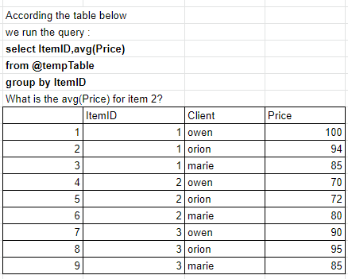



3. *

10 puan

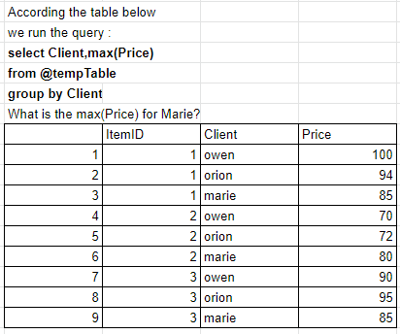



4. *

10 puan

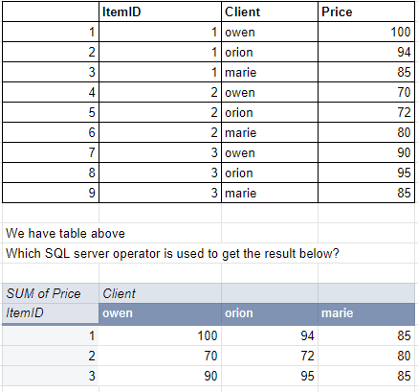

Rotate

Unrotate

*Pivot

Unpivot

5. We have table TotalSales and ZipCode. Which fallowing functions should we use to get the first 2 columns in the picture below? *

15 puan

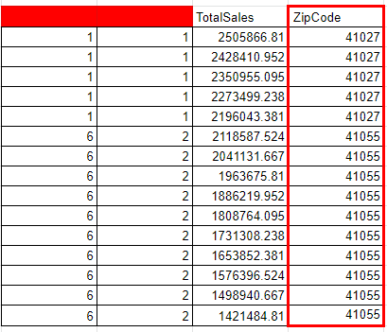

Rank and Ntile

Row_number and Ntile

*Rank and Dense_rank

Dense and Ntile

6. *

10 puan

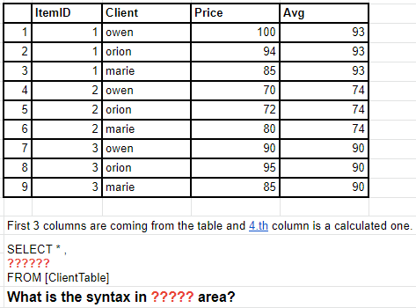

avg(Price)

*avg(Price) over(partition by ItemID) as Avg

sum(Result) / count(*) as Avg

sum(Result) / count(*) over(partition by ItemID) as Avg

7. Match the sentences with SQL operations. *

15 puan

Remove all records from a table permanently TRUNCATE

It is used to delete existing records from an existing table. DELETE

Delete objects from the database DROP

SELECT OrderID, FirstName, LastName, City, Country

FROM Order O JOIN Customer C ON O.CustomerID=C.CustomerID8. Write a basic SQL query that lists all orders with customer information. we have order tables and customer tables that contain the following columns: *

10 puan

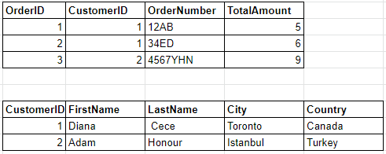



9. Print the rows which have ‘Yellow’ in one of the columns C1, C2, or C3, but without using OR. *

10 puan

